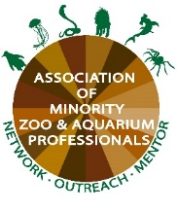
AMZAP Entry-Level Animal Husbandry Program at the Smithsonian’s National Zoo

The AMZAP Entry-Level Animal Husbandry Program is designed to introduce students and aspiring animal husbandry professionals to the zoological field while simultaneously allowing them to work and/or attend school. This is a hybrid program that will combine two in-person days and additional virtual learning assignments each week. Program participants will attend in-person at the Smithsonian’s National Zoo (Rock Creek campus) in one of two units, either the Lion/ Tiger Department or the Primate Department. All participants will have additional assignments that could include virtually meeting with zoo professionals, reading related articles, and brief assignments as needed.
Throughout the program, participants will learn the fundamentals of caring for animals in a zoo setting which can include diet and enrichment prep, cleaning exhibits and enclosures, learning safety protocols, guest interactions, animal observations and record keeping, operant conditioning, and more. Participants will network with current zoo professionals, learn about various careers in the zoo field, and explore whether the zoo field is a good professional fit for them. Assignments and opportunities that are available to the ELHP intern are based on individual progress during the internship.
By the end of the program, participants should know if they’d like to pursue a career in the zoo field and should have enough experience to compete for other opportunities, including entry-level paid positions.
Who Should Apply: This opportunity is being provided by The Association of Minority Zoo & Aquarium Professionals, which is focused on increasing the representation of racial and ethnic minorities in the zoo & aquarium field. As such, we hope to attract heavy interest from individuals who identify as BIPOC (Black, Indigenous, or Person of Color). However, the opportunity is open to anyone who thinks that they may aspire to become a professional animal keeper. Students, recent graduates, or individuals in the workforce with little to no experience in a zoo setting are encouraged to apply. Current students will receive support to earn college credit for their time spent in the program.
Requirements:
- Minimum 20 years of age
- Professional, hardworking, and passionate about a potential career in the zoo field
- Ability to work in all types of weather for long periods of time
- Ability to lift 50 lbs
- Must be able to commit to two days in person, between 6:30am and 5pm, and one additional hour of virtual learning per week between March 1 and May 15, 2023
- Ability to work independently and in a team setting
- Follow safety protocols as directed by staff at all times
- Must provide proof of negative TB test and be willing to submit to a background check
- Interns may be required to do a project that must be completed at the end of the internship.

The Spring 2023 program will take place March 1, 2023, to May 15, 2023. Write to powellc@si.edu with any questions or to submit your application.
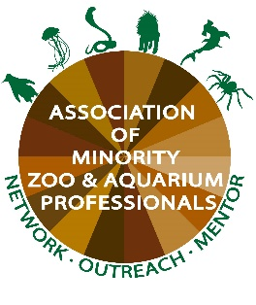
AMZAP Entry-Level Animal Husbandry Program at the Smithsonian’s National Zoo

APPLICATION
Name:
Preferred Pronouns:
Email:
Phone:
Age:
Days of the week available:
Preferred unit (Lion/ Tiger or Primates):

To complete your application, please include a resume and a personal statement (1 page max). In your personal statement, please answer the following questions: Why do you want to participate in the AMZAP Entry-Level Animal Husbandry Program. What, if any, previous animal care (at any level) experience do you have? If applicable, how has your experience as a BIPOC (Black, Indigenous, or Person of Color) influenced your career path so far? Your personal statement will be given the greatest weight in the application process.
Applications are due by January 15, 2023, for the Spring 2023 program. Submit all applications to Carolina Powell at powellc@si.edu.

